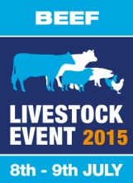
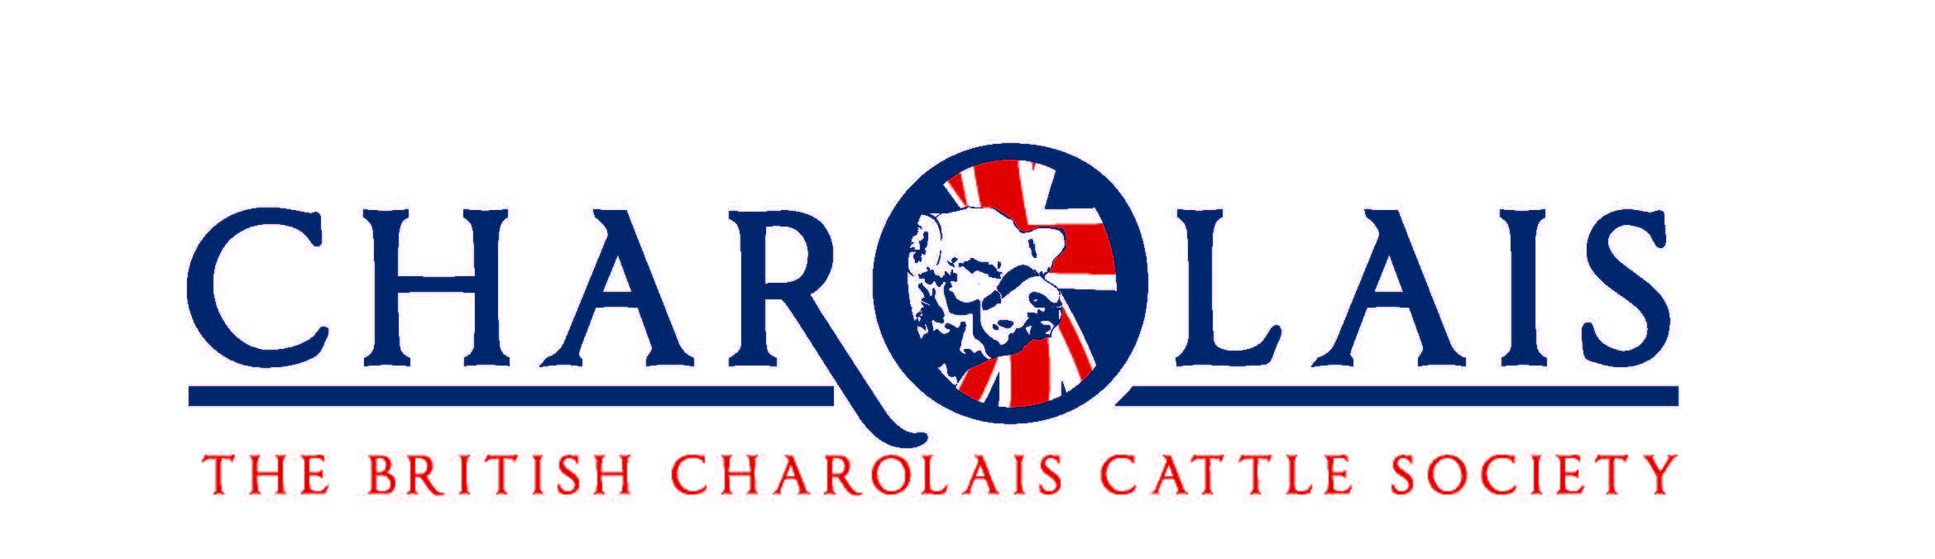
National Charolais Show 2015 – 8th & 9th July
Booking Form – Cattle Stalls and Stockman Accomadation
Stall Booking Closing Date 5th June 2015
Exhibitor Name
Contact Name
Herd Prefix
Address | Postcode
Telephone | Home:
 | Mobile:
Email

Beef Cattle Stall Booking Form
Charolais | Number Stalls @ £50 + VAT each (£60 inc VAT) | Amount Due
Number |  | £
Total Stall Booking Fee |  | £

Stockmans Accommodation Booking Form
Quantity | Accommodation | 3 Nights | Total
 | Caravan Space | £50 + VAT  (£60.00 Inc VAT) | £
 | Lorry Sleeper Space | £50 + VAT  (£60.00 Inc VAT) | £
Total Stockmans Accommodation |  |  | £

Total Payment
Total Stall Booking | £
Total Stockmans Accommodation | £
TOTAL PAYMENT | £

Payment Method
I enclose a cheque made payable to RABDF Events
Please charge my credit card for the remittance
Name on Card | Card Type (we are unable to accept American Express) | Card Number
Security Code | Expiry Date

I agree to abide by the ‘RABDF Events Rules and Regulations for Showing Bovine Animals and Standard Procedures and Penalties for Enforcement’ at the Livestock Event, and enclose my remittance for £............. made payable to RABDF Events.
Name ............................................................ Signature........................................................... Date ...........

Please make cheques payable to RABDF Events and return along with this form to:

Sian Mercer, RABDF, Dairy House, Unit 31, Abbey Park, Stareton, Kenilworth, Warwickshire, CV8 2LY

Tel: 0845 458 2711 Email: sianmercer@rabdf.co.uk

STALL BOOKINGS CLOSE
5th June 2015
ENTRIES CLOSE
5th June 2015
www.livestockevent.co.uk

 | National Charolais Show Manager
Event Organiser |  | Principal Sponsor

